User Instruction for Tag Now laser label (9.91x6.78cm)

A.
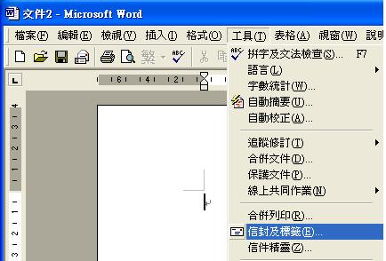
- Open Microsoft Word
- Select工具
- Select 信封及標籤

B.
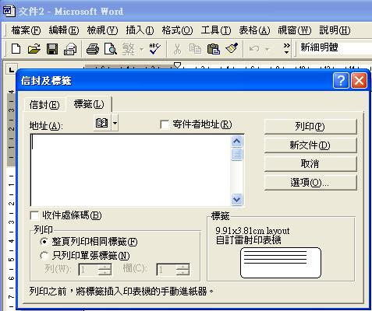
- Select 標籤
- Select 選項

C.
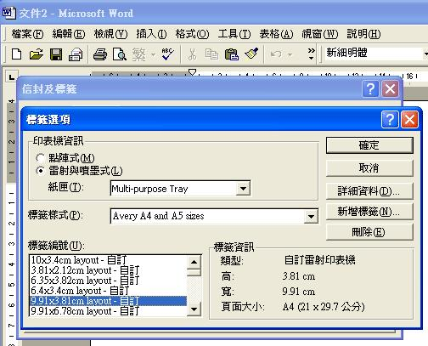
6. Select 新增標籤

D.
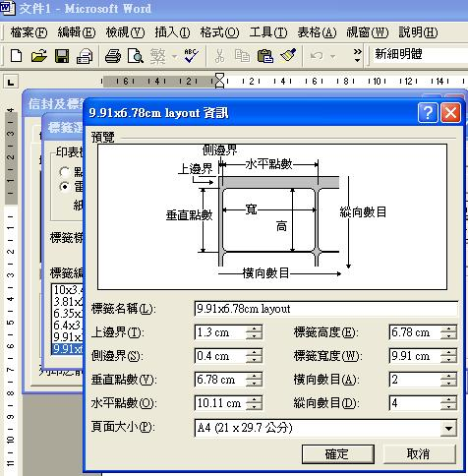

7. Please input all the above value in the box
8. click 確定

E.
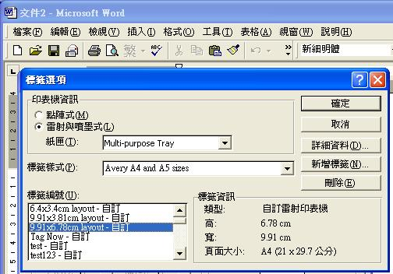
9. 9.91x6.78cm layout-自訂 顯
示在標籤編號內
10. Highlight 9.91x6.78cm layout
11.Select 確定

F.
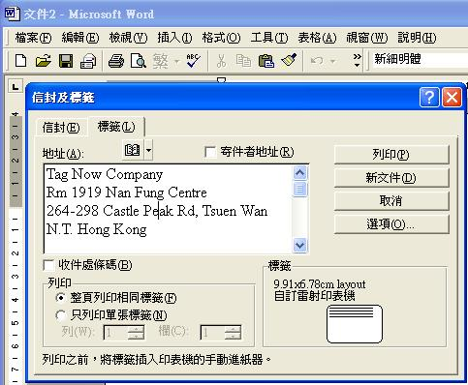

12. Input your information
13. Input your 9.91x6.78cm label
sheet into your laser printer
14. Select 列印

If you have any query, please feel free to call Tom at 65925030

Tag Now Company
Rm 1919 Nan Fung Centre
264-298 Castle Peak Rd, Tsuen Wan
N.T. Hong Kong
Tel: 24701355 Fax: 24702355
www.tagnowhk.com

